PRACTICAL RISK MANAGEMENT ONLINE
Veroslav KAPLAN¹, Jiri KOZEL², Tomas REZNIK³, Zdenek STACHON⁴
¹veros @mail.muni.cz, ²jirikozel@centrum.cz, ³tom@mail.muni.cz, ⁴zstachon@gmail.com
Masaryk University, Faculty of Science, Department of Geography,
Laboratory on Geoinformatics and Cartography
Kotlarska 2, 611 37 Brno, Czech Republic

Introduction
Risk management is the process of measuring or assessing risk and developing strategies how to manage it. Traditional risk management focuses on risks stemming from physical or legal causes (e.g. natural disasters or fires, accidents, deaths, and lawsuits). However, there is also a geoinformatical point of view and this approach is based on map production and map use to simplify decision support process in risk management.

TRANSPORTATION OF HAZARDOUS CHEMICAL MATERIALS
The case study of this research is a transport of hazardous chemical materials. The case study focuses on the development of a system that provides all necessary functionality for the prevention of dangerous load disaster and functionality for emergency in case of this disaster.

Table 1 – Number of accidents in the process of the hazardous material transportation in years 1998 – 2003 (Safr, G., 2004).
Accidents / years | 1998 | 1999 | 2000 | 2001 | 2002 | 2003
Number of accidents | 3469 | 3852 | 3768 | 4156 | 6232 | 6563
including oil accidents | 2779 | 3147 | 3141 | 3596 | 4965 | 5404

The chemical industry of the Czech Republic belongs to the field that is with its almost 6000 enterprises an important part of the national industry (Safr, G., 2004). Production in those chemical enterprises is professionally protected against the escape of hazardous material and spatially delineated. However, hazardous chemical material needs to be transported to other places. According to the statistical data (Safr, G., 2004) the number of accidents in the process of the hazardous material transportation is growing (see Table 1).
Transport of hazardous chemical materials is a phenomenon affecting the whole area of the Czech Republic with its danger and both, spatial and temporal unpredictability. Those materials are in the Czech Republic transported in two ways – on the road and by the railway. These are the main reasons for developing a system for map support for early warning and map support for the disaster itself. That is why this paper is not focused on a description of different kinds of Web services as they are already widely known. Instead of this, it focuses on possibilities of Web services integration and their meaningful use in a daily life of rescue workers.

SYSTEM OF MAP SUPPORT FOR TRANSPORT OF HAZARDOUS CHEMICAL MATERIALS
This system composes of two subsystems: terrain and office. The terrain subsystem contains sensor equipments (including transport and hit sensors that are OGC – Open Geospatial Consortium – compliant) and GPS locator. The purpose of this subsystem is to identify the location of the dangerous load and to send the information about the disaster. All relevant information is wireless transferred (GPRS; General Packet Radio Station) to the office subsystem. GPRS is used especially due to low costs and efficiency.
The office subsystem consists of software mediator (which is responsible for receiving information from terrain subsystem and its conversion to understandable format), UMN (University of Minnesota MapServer that online combines data from mediator, local and distributed databases while using WMS and WFS), route planner (for a definition of the most effective route between appropriate emergency centre and a place of dangerous load disaster) and SMS service (for better awareness of end users – crisis centre employees, mayors, etc.). Furthermore, the system uses the context cartographic visualization that is based on change of used cartographic method according to user’s need. For example, fire brigade, emergency or police have different user’s need.
The main goals of the case study are following:
- To verify the functionality of theoretical aspects of geovisualization
- To verify the functionality and interoperability communication and information technology of the system
- To test different types of GPS receivers
- To verify the coordination with the risk management bodies
- To test the ability of the research team to fulfill related work

TERRAIN SUBSYSTEM
Systems working as the GPS receivers have been used for survey of the position, however, the position was not the only value – there have been also evaluated GPS signal quality and GPRS (General Packet Radio Service) signal quality.
The transporting vehicle has additional hardware device (see Fig. 1) with sensors (i. e. anemometer, speedometer, and accelerometer), computer, GPS device, GPRS modem and LED display inside. All hardware components are water-proof and located in the device itself, except for possible external GPS antenna (placed on the roof of the vehicle).

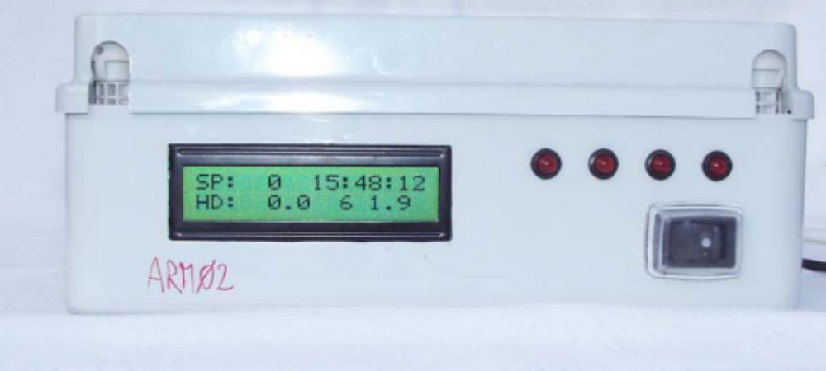
Figure 1 – Additional hardware device for transporting vehicle.

In simplified way, the hardware device receives the GPS signal, evaluates signal quality and sends this information to both, the LED display (for the crew of the transport) and to the mediator at the server side (via GPRS).
As it was written, the transport vehicle contains also a set of sensors connected as a sensor network. A sensor network is a computer accessible network of many spatially distributed devices using sensors to monitor conditions at different locations, such as temperature, sound, vibration, pressure, motion or pollutants. A Sensor Web refers to web accessible sensor networks and archived sensor data that can be discovered and accessed using standard protocols and application program interfaces (APIs). OGC’s Sensor Web Enablement (SWE) activity, which is being executed through the OGC Web Services (OWS) initiatives (under the Interoperability Program), establishes the interfaces and protocols that will enable a “Sensor Web” through which applications and services will be able to access sensors of all types over the Web.
To ensure interoperability, sensors in our hardware device are connected in the OGC SWE compliant schema. Used sensors are: thermometer, speedometer, anemometer and accelerometer (to ensure the accident, which could also be defined as the speed deceleration that is higher than speed deceleration with breaks of the vehicle).
Transfer of data has been tested via GPRS while using UDP protocol that enables controlling the number of sent packets with unified identification (ID). Example of the GPS packet and visualization of the vehicle position is shown in Figure 2.

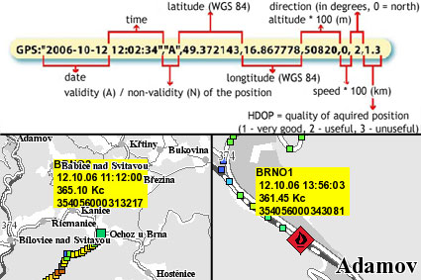

Figure 2 – GPS position and signal quality as defined in UDP packet.

OFFICE SUBSYSTEM
The whole case study solution, including both terrain and office subsystem, consists of several modules (see Figure 3). Localization module represents terrain subsystem, which was described in detail above (see chapter 2). Communication module then makes a bridge between terrain and office subsystem. Communication module is divided into two parts: first part related to localization module transfers information between vehicle and database module, whereas second part receives information about the accident (see bellow) and controls communication with database module and Integrated Rescue System (Fire Brigade, Police and Ambulance). Database module stores spatial data, sensor data and rescue plans. It shares the data with geoinformatic module, which is responsible for contextual maps generating.

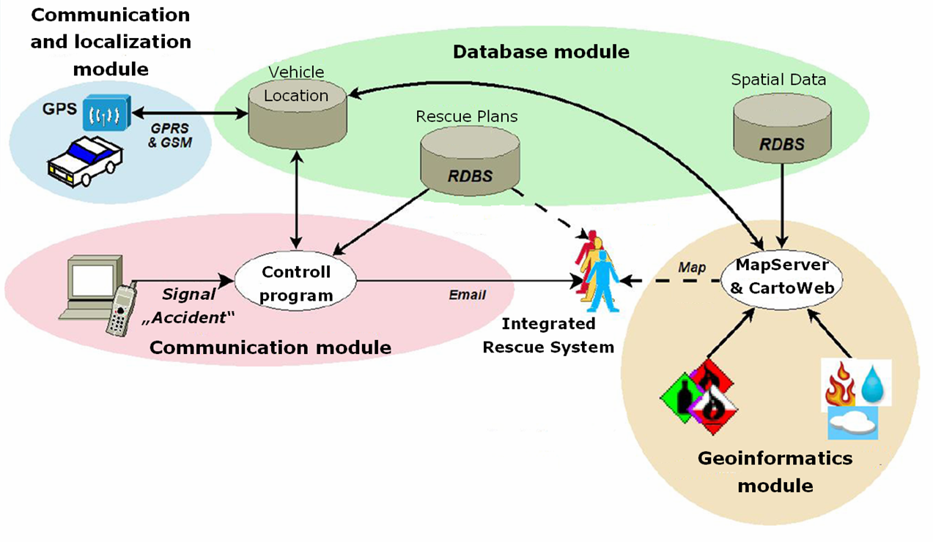
Figure 3 – Schema of the case study modules.

Communication module
Heart of communication module is represented by Control program. It is a program, which is able to receive information about accident (i.e. by a cell phone). After receiving specific signal, the program automatically selects information about location of crashed vehicle, transported hazardous chemical material and vehicle sensor data, all from database module. Concerning all data, the program selects corresponding rescue plan and also context (see bellow). Finally, the program compiles full report about accident and sends it to Integrated Rescue System units. The report contains also hypertext links to corresponding contextual maps (see bellow) and instructions for rescue intervention.

Database module
Main task of database module is quite simple: to store vehicle location, sensor data, spatial data and rescue plans. Because risk management requires interoperable solutions, it was decided to store spatial data in database, which implements Simple Features Specification (SFS) designed by OGC. Concerning this, a relational database system PostgreSQL [http://www.postgresql.org/] with extension PostGIS [http://postgis.refractions.net/], both released under an open source license, was chosen. PostgreSQL and PostGIS were able to process about 1 GB of spatial data without any difficulty during the testing period in autumn 2006, so these applications are recommended for future work.

Geoinformatic module
Geoinformatic module ensures the process of contextual cartographic visualization, which is part of dynamic geovisualization. Contextual cartographic visualization (also adaptive cartographic visualization) is a process of generating maps related to specific context. Main ability of the process is to highlight relevant spatial information and to suppress or to omit the irrelevant corresponding to the context.
The context is a set of characteristics related to the user of the map, purpose of the map, environmental conditions during map perception, display device, etc. All these characteristics determine how the contextual map will appear (including map content, extent, level of detail, scale, symbolization etc). See Figure 4 for examples.

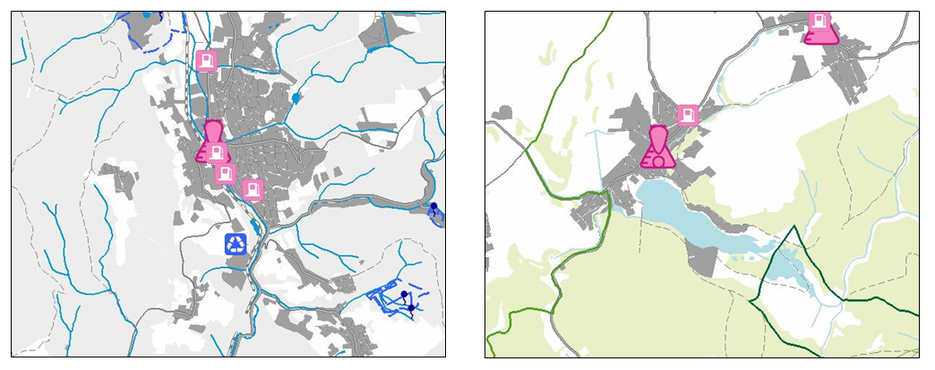
Figure 4 – Examples of contextual maps with different content, extent
and symbolization.
Contextual cartographic visualization is still in experimental stage, which also means that there exist neither any known standard, which would specify it, nor any known software, which would directly support it. Concerning this, we had to build our own solution for testing purpose for a case study “Transport of hazardous chemical materials” held in autumn 2006.
The solution was based on UMN MapServer [http://mapserver.gis.umn.edu/] and its extension CartoWeb [http://www.cartoweb.org/], both released under an open source license. Whereas UMN MapServer provided just cartographic visualization, the “contextual” part was provided by CartoWeb.

CONCLUSIONS AND FUTURE WORK
This paper shows the possibilities of cartography and geoinformatics for risk management – especially in the fields of early warning and map support for an accident itself. All approaches have been tested in autumn 2006 in a case study called “Transport of hazardous chemical materials”.
Chapters 2 – 4 described the architecture of our solution that is divided into two parts: terrain and office subsystem. Terrain subsystem contains GPS module and sensor equipment integrated as the sensor network according to the OGC draft of specification Sensor Web Enablement (SWE). Office subsystem consists of several modules (communication and localization, communication, database and geoinformatic) while each one is responsible for different functionality.
From the cartographic point of view the fundamental idea lies in context cartographic visualization that could be defined as a process of generating maps related to specific context. Main ability of the process is to highlight relevant spatial information and to suppress or to omit the irrelevant corresponding to the context. The context is a set of characteristics related to the user of the map, purpose of the map, environmental conditions during map perception, display device, etc. All these characteristics determine how the contextual map will appear (including map content, extent, level of detail, scale, symbolization etc).
Although the solution fulfilled conditions of the case study, there appeared some problems, which could not be accepted for the future development. First, the solution was not interoperable, because CartoWeb is not able to provide contextual maps even through WMS specification. CartoWeb has also low extensibility and low customizing level, which means that contextual visualization is basically possible through CartoWeb but only in a very simple way and with many restrictions. The solution is also dependent on both UMN MapServer and CartoWeb.
Concerning this, it was decided to build a new solution based on OGC specifications Web Map Service (WMS) and Styled Layer Descriptor (SLD), which should solve most of these problems. Development of the solution started at the beginning of 2007 and first version should be finished at the end of the year.
This research has been supported by funding from Project No. MSM0021622418 called Dynamic Geovisualization in Risk Management.

REFERENCES:
- Bandrova, T., Konecny, M. (2006): Mapping of Nature Risks and Disasters for Educa-tional Purposes in Conference Collection of Papers, Volume II, VIth International Scientific Conference „Modern Management of Mine Producing, Geology and Environmental Protection SGEM2006“, s. 127-134. Albena, Bulgaria.
- Friedmannova, L., Konecny, M., Stanek, K. (2006): An adaptive cartographic visualization for support of the crisis management. Auto-Carto 2006, Vancouver.
- Kozel, J., Reznik, T. (2007): Mapove sluzby v krizovem rizeni. In Sbornik prednasek Informacnich systemu v zemedelstvi a lesnictvi. ISZL, 2007, Praha. ISBN 978-80-213-1643-0.
- Kozel, J., Mulickova, E., Kubicek, P. (2007): Vyuziti kontextove vizualizace pri sledovani prepravy nebezpecnych nakladu. In Sbornik prednasek Mezinarodniho kongresu o interoperabilite v krizovem rizeni. Interop-soft 2007. ISBN 978-80-86633-91-6, s. 47-53, Brno.
- Kubicek, P., Stanek, K.: Dynamic visualization in emergency management. In: Proceedings of, First international conference on cartography and GIS, s. 40, Sofia, 2006. ISBN 954-724-028-5.
- Kubicek, P., Talhofer, V. et al. (2006): Preprava nebezpecneho chemického nakladu – interni zaverecna zprava pilotniho projektu. Vyzkumny zamer MSM0021622418, Brno. URL: <http://geokrima.geogr.muni.cz>.
- Open Geospatial Consortium (2002): Styled Layer Descriptor Implementation Specification v. 1.0.0, OGC dokument #02-070. URL: <http://www.opengeospatial.org/standards/sld>.
- Open Geospatial Consortium (2005): Web Feature Service Implementation Specification v. 1.1.0, OGC dokument #04-094. URL: <http://www.opengeospatial.org/standards/wfs>.
- Open Geospatial Consortium (2002): Web Map Service Implementation Specification v. 1.1.1, OGC dokument #01-068r3. URL: <http://www.opengeospatial.org/standards/wms>.
- Safr, G. (2004): Preprava nebezpecnych latek na uzemi České republiky. In Sbornik konference Krizovy management, Brno. ISBN 80-85960-71-0.
- Reznik, T. (2005): Interactive maps. In XXII International Cartographic Conference, Abstracts of Papers. A Coruna: Comite organizador ICC 2005. 10 s. ISBN 0-958-46093-0.

